FISHING ROD RAFFLE 2024

"Tsunami Airwave Elite Light Surf Spinning Rod"
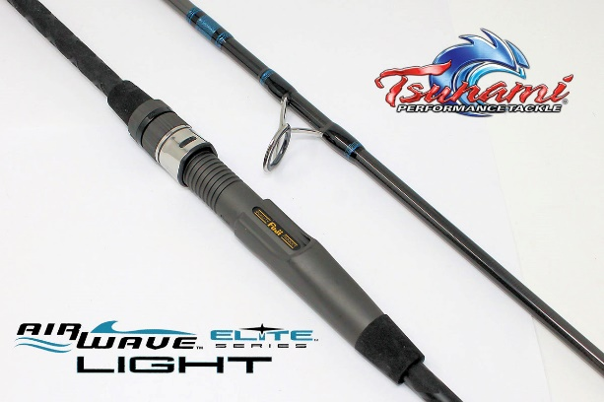
The TSAWESS-802LT, is a 2-piece (70/30 split), 8’0” rod, designed for light tackle applications all along the coast. The Tsunami Airwave Elite Light Surf Spinning Rods are perfectly suited for land-based anglers fishing from sod banks, jetties, beaches, and more. These super light and comfortable to fish surf rods provide excellent performance with lighter line and lure techniques commonly used in backwater environments. Anglers will find them perfect for things like jigging for fluke with bucktails and soft plastics, fishing smaller top waters for schoolie stripers, and plenty of other techniques for mid-sized inshore species.
The Airwave Elite Light series is built on high-fiber graphite blanks with impressive fighting power despite their light weight and limber actions. The high-pressure production methods increase blank density, making them ultra-sensitive for picking up on lighter bites.
This rod matches perfectly with spinning reels like the Daiwa BG3000 or the BG MQ3000.

$10.00 / TICKET

Raffle will begin at March Meeting..!!
Ticket to be drawn at September Meeting..!!

