To All MFC Members

“Magic Hour Black Sea Bass Charter”

aboard the 85’ Queen Mary – Point Pleasant

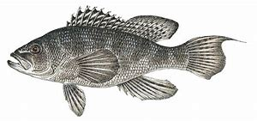

05/21/24 (Tues) … 3PM – 8:30PM…"Magic Hour Trip"

$100 + $20 tip / person… Limited to 20 people!!

Be at dock by 2:30 PM - Departure at 3:00 PM

Currently this trip is full, add your name to the Stand-By List

All Payments cash or checks made to MANASQUAN FISHING CLUB!!

Contact MFC Treasurer ASAP!! – Ja

ck Pongracz @ 732-580-6147

