**To All MFC Members**

*“Magic Hour Black Sea Bass Charter”*

aboard the 85’ Queen Mary – Point Pleasant

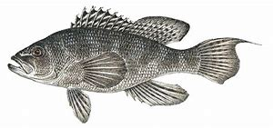

05/20/25 (Tues) … 2:30 PM – 8:30 PM…"Magic Hour Trip"

$100 + $20 tip / person ($120.00)

**Limited to 20 people!!**

Arrive at dock by 2:00 PM - Departure at 2:30 PM

***Currently this trip is full***

***Add name to the Stand-By List***

***All Payments cash or checks made to MANASQUAN FISHING CLUB!!***

Contact MFC Treasurer ASAP!! – Jack Pongracz @ 732-580-6147