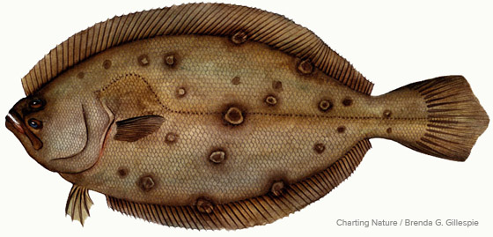

**MANASQUAN FISHING CLUB**

**OCEAN FLUKE TOURNAMENT 2025**

**THURSDAY, JULY 17th - 8:00 am till 2:00 pm (Rain or Shine)**

**Sea Girt Reef to Axel Carlson Reef or Half-Day Party Boat (AM) Trip**

**$40.00 per person (includes fishing fee, picnic food and soft drinks)**

**Weigh-in / Meal to follow at the Manasquan Community Senior Center at 4:00 pm**

**RULES:**

1. Tournament open to all MFC members and any number of family members. Each MFC member is allowed one guest (not a family member) that must be over 18 years old.
2. MFC member / adult family member / guest - fishing / picnic fee = $40.00. Youth family member (under 18 years old) - fee = $20.00. Attending picnic only - meal fee = $20.00.
3. Lines in at 8:00 am, lines out at 2:00 pm!!
4. All participants **MUST** check in by 11am via cell number **732-580-6147**.

* Regardless of your start time, you must check in before you begin fishing.
* ***Any fish presented for weigh***-***in without pre-checking in will not qualify for prizes!!***
* You will only attend the picnic, you must check in.

1. **Fishing restricted to areas bounded by northern edge of Sea Girt Reef and by the southern edge of the Axel Carson Reef!!**

* Shore bound anglers - Fishing allowed at Manasquan Rail / Inlet, Point Pleasant break-wall, and Ocean from beach and/or jetties.
* Party Boat Half-Day (AM) trip on Fluke Tournament Day only!!

1. There will be three prizes for adult participants (from fishing fees collected):

* 1st - 50%, 2nd - 30% and 3rd - 20%.
* ***Winners will be determined by the Heaviest Legal Fluke!!***
* In the event of a tie, length will be the deciding factor!!
* ***All anglers are limited to one fish entry per person and one prize permitted per fishing fee paid!!***

1. If no Legal Fluke are presented for weigh-in:

* 50% of proceeds shall go to MFC.
* 50% shall be drawn from a hat for 1st, 2nd, and 3rd (being divided as per rule 6).

1. If only one Legal Fluke is presented for weigh-in:

* 2nd and 3rd places shall be determined by drawing from a hat (being divided as per rule 6).

1. If only two Legal Fluke are presented for weigh-in:

* 3rd place shall be determined by drawing from a hat (being divided as per rule 6).

1. Youth family members who catch a Legal Fluke will be given the option of claiming an apparel item of their choosing (hat or shirt) as their prize.
2. There will also be a “Sea Robin Calcutta,” fee will be $5.00 – one prize for heaviest fish.

**Ocean conditions will determine change of date!!**

* If NOAA forecast (by 8 pm on the night before), indicates ≥ 3-5 ft seas / small craft advisory, event date will be cancelled.

***We hope to see you there!***