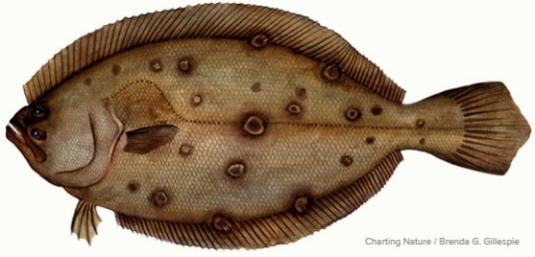

**MANASQUAN FISHING CLUB**

**RIVER FLUKE TOURNAMENT 2025**

**TUESDAY, JUNE 17th** - **12:00 noon till 5:00 PM (Rain or Shine)**

**MANASQUAN RIVER ONLY (from boat or from shore)**

**$40.00 per person (includes fishing fee, picnic food and soft drinks)**

**Weigh-in / Meal to follow at the Manasquan Community Senior Center at 6:00 pm**

**RULES:**

1. Tournament open to all MFC members and any number of family members. Each MFC member is allowed one guest (not a family member) that must be over 18 years old.
2. MFC member / adult family member / guest - fishing / picnic fee = $40.00. Youth family member (under 18 years old) - fee = $20.00. Attending picnic only - meal fee = $20.00.
3. Lines in at 12:00 noon, lines out at 5:00 pm!!
4. All participants **MUST** check in by 12 noon via cell number **732-580-6147**.

* Regardless of your start time, you must check in before you begin fishing.
* ***Any fish presented for weigh-in without pre-checking in will not qualify for prizes***!!
* You will only attend the picnic, you must check in.

1. **Fishing limited to the Manasquan River only!!**

* Boaters - The Point Pleasant Canal, Manasquan Inlet and Ocean are **OFF LIMITS!!**
* Shore bound anglers - Fishing allowed at Manasquan Rail, Dog Beach, Point Pleasant break-wall, Riverfront Park break-wall and any other fishing pier / marina on the river.
* **Jetties are OFF LIMITS!!**

1. There will be three prizes for adult participants (from fishing fees collected):

* 1st - 50%, 2nd - 30%, and 3rd - 20%.
* ***Winners will be determined by the Heaviest Legal Fluke!!***
* In the event of a tie, length will be the deciding factor!!
* ***All anglers are limited to one fish entry per person and one prize permitted per fishing fee paid!!***

1. If no Legal Fluke are presented for weigh-in:

* 50% of proceeds shall go to the MFC.
* 50% shall be drawn from a hat for 1st, 2nd, and 3rd (being divided as per rule 6).

1. If only one Legal Fluke is presented for weigh-in:

* 2nd and 3rd places shall be determined by drawing from a hat (being divided as per rule 6).

1. If only two Legal Fluke are presented for weigh-in:

* 3rd place shall be determined by drawing from a hat (being divided as per rule 6).

1. Youth family members who catch a Legal Fluke will be given the option of claiming an apparel item of their choosing (hat or shirt) as their prize.

***We hope to see you there!***