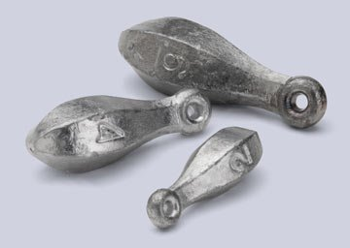

WHERE:
Dome Sheet Metal
712 16th Avenue
Belmar, NJ 07719

WHEN:
04/06/24 (Sat. - Weather Permitting) … 9:00 AM - 1:00 PM
Coffee & Donuts will be provided

MUST HAVE:
Safety Glasses or Goggles
Leather Gloves & Pliers
Can (For your sinkers)

This is a Great Activity exculsive to Dues Paid MFC Members
“We request a $10 fee to everyone making sinkers
and a donation for using hooks”

Fishing Reel Line Spooling On-site – “Must bring your own line”

